‘Millennials and centennials' perspective on Streaming narratives in Spain and Mexico: Spiral of silence, bandwagon effect, and third person effect
Abstract: Viewers are increasingly used to the link between entertainment and technology in the current media ecosystem. The success of consuming streaming platforms when watching movies and series shows how the audience is more involved in new forms of viewing, at any time, at any moment, and with any content. This research aimed to examine the perception of millennial and centennial audiences in Spain and Mexico, the two Spanish-speaking countries with the highest streaming consumption, about audiovisual content producers for entertainment. Three theories on public perception (spiral of silence, bandwagon effect, and third-person effect) were used as the basis of the research questions to unravel the extent to which younger audiences in these countries consider that production companies are, or are not, ethical in the representation of what may be labeled as "sensitive topics". The results show that centennials are more confident in their critical perceptions of controversial issues in movies and series, while, on the other hand, millennials approach their perceptions with more cautiousness and confusion.
Keywords: Bandwagon effect; millennials; centennials; spiral of silence; streaming; third-person effect

- Introduction
The perception of public opinion and human behavior is largely linked to the media. However, the traditional medium of consumption has changed radically in recent years. Media audiences now occur atawad, an acronym for anytime, anywhere, and on any device. There is even talk of atawad+ac, incorporating any content into the formula (Hernández-Pérez & Rodríguez-Mateos, 2016). Media consumption is nowadays, in many cases, multiscreen and multitasking. As a result, contemporary audiences do not want to feel tied to the schedules programmed by the channels but can choose to watch the content whenever they wish, either by recording it (time-shift) or by streaming it (VOD or on-demand television). (Quintas-Froufe & González-Neira, 2016).
Therefore, the form of entertainment consumption has changed, returning to the media disseminators of the simulacrum in postmodern cultures, where technologies have come to modify "radically the perception and experiences of people", cementing what Baudrillard called "hyperreality" (Von Werder, 2013).
Unraveling the psychological roots of public opinion has become as complex a task as unmasking reality. Along these lines, theories of public perception and political sentiment, such as the spiral of silence, the bandwagon effect, and the third-person effect, have attempted to answer the question of human behavior in the face of different forms of communication.
This study examined the beliefs of younger audiences (millennials and centennials generations) in Spain and Mexico concerning these psychological and public opinion theories when consuming audiovisual entertainment on their streaming platforms. Therefore, first, we will explain the main characteristics of the spiral of silence, a theory promulgated by political scientist Elisabeth Noelle-Neumann in 1974; second, the bandwagon effect and, finally, the third-person effect, enacted by W. Phillips Davison in 1983.
  - Spiral of silence
The spiral of silence began in the 1960s when Noelle-Neumann started researching public opinion, eventually establishing this theory that would serve to understand the impact of the media on the individual. Very briefly, the spiral of silence establishes - among other things - that the dominant current of opinion, or the one perceived as the prevailing one in society, generates the effect of attraction that increases its final strength (Contreras Orozco & Pablo Porras, 2016).
This situation might occur in closed and intimate circles such as, for example, in families, and it also happens when authority actors develop certain opinions on some issues, encouraging group members to adhere to the way of thinking of such actors in order to avoid conflicts, also achieving that those who do not join such belief are considered as weak, outcasts, isolated and with a repressed individuality (Contreras Orozco & Pablo Porras, 2016). In short, the spiral of silence postulates that the willingness of individuals to express opinions derives from their perceptions of the dominant opinion (Kushin et al., 2019).
Noelle-Neumann's central thesis was that people try to avoid isolation in controversial issues where values are at stake. In this sense, the spiral of silence determines that people who observe the social ecosystem notice that their criteria, in terms of values or opinions, are considered or given importance. That is, they feel strong and lack the fear of isolation, so they are not afraid to express their opinions in public, whether known or anonymous, since they are self-confident. On the other hand, those who perceive that their different opinions are losing strength become more cautious and remain silent. As a result, one group expresses its opinion calmly while the other does not, contributing to the fact that the issue in question is presented in a certain way to the public (Noelle-Neumann, 1993).
Hence, the spiral of silence theory proposes that individuals are likely to speak out publicly if they perceive themselves as a present or future majority on an issue (Poulakidakos et al., 2018, p. 374). In this way, people closely follow their social environment through the media to assess the opinion climate.
In her early research on the spiral of silence, Noelle-Neumann discussed controversial topics with the study subjects, such as abortion, blood alcohol levels, the death penalty, non-married couples living together, children's physical punishment, or the prohibition of the communist party. One of the findings was that willingness to discuss in public varies by gender, age, occupation, income, and residence: "men, the young, and the middle and upper classes are generally the most likely to speak up, and these differences hold for all other findings" (Noelle-Neumann, 1974, p. 46).
In this way, the spiral of silence presents the media as part of the individual's system to gather information about the surrounding context (Noelle-Neumann, 1974, p. 51), i.e., the prevailing climate of opinion. Therefore, everything fenced off beyond his personal or private core can only be known through the media. Consequently, the individual will react, as a matter of course, to the pressure of opinion as a public fact. In this sense, for Noelle-Neumann, the media should be seen as creators of public opinion: they provide the environmental pressure to which people respond with readiness, acquiescence, or silence.
ICTs have changed how people get information. While traditional journalism used to be the only way of information accessible to large audiences, in the current era, new sources have emerged in the digital ecosystem, fostering an age in which anyone can provide information in a digital format (Poulakidakos et al., 2018). In other words, the proliferation of information sources has increased the diversity of opinions. Therefore, given that the causal relationship between exposure to certain media content and the expression of opinions in public is the backbone of the concept of the spiral of silence, it is as relevant today as ever to talk about this theory (Poulakidakos et al., 2018).
Likewise, it happens in digital media, and not only in the real environment, that "the rawer a controversy is, the more supporters of opposing viewpoints avoid each other" (Noelle-Neumann, 2010, p. 315). In this way, there is a tendency to avoid mutually differing points of view, thus fostering homophily and "digital ghettos" (Noelle-Neumann, 2010).
On the other hand, the media are also fundamental to understanding the spiral of silence: If we consider the journalistic functions of "agendizing, thematizing or silencing" as the meaning of "knowing, defining, giving opinions, solving, imposing, controlling political activity" (Santillán Buelna, 2015, p. 17), we conclude that it is the media that also participate and promote to whom the silence (weakness) is directed and to whom the noise (strength) is addressed. The spiral of silence, as well as many studies related to agenda setting, are based on the cognitive effects of communication, arguing that media coverage does not only depend on the amount of information or emphasis given to political issues nor on the number of actors involved" (Santillán Buelna, 2015).
Social networks have opened the doors to other visions of the spiral of silence theory. At present, as information monopolies disappear, sources are democratized, cooperative dynamics are given priority over the isolationism of the 20th century, the way is opened to mobile connection (with half of the world's population owning a smartphone), and the digital divide is reduced, creating, increasingly, that information does not belong to an absolute owner: "A world capable of showing you from how to iron pants to how to build a bomb with a ping pong ball" (López-Bonafont, 2011, p. 222).
However, although this scenario seems to be the end of the spiral of silence, it has not been entirely achieved since the professionalization of the use of social networks has turned the Internet into a battlefield in which companies, political parties, and NGOs fight it out to reach their target audiences. For example, generation Y has been losing its "assimilation capacity", becoming saturated by all the constant novelties on the web (López-Bonafont, 2011, p. 223).
Of course, in this war, there are companies, parties, and NGOs aimed at getting all the people who make life on the network into their space, and they are the ones who dictate the rules in a chaotic world. In this way, these groups build an eternal "cohesive and identified" that absorbs the user and, consequently, "the spiral of silence is reproduced on the Internet with the same vices that characterize it outside it" (López-Bonafont, 2011, p. 225).
A 2016 Pew Research study on the use of social networks as a channel for expression showed that networks perpetuate the theory of the spiral of silence. This is because users tend to silence opinions if they consider them to be unpopular or not in the majority (Contreras Orozco & Pablo Porras, 2016). In that study, participants "were less willing to express their opinions on social networks than in front of a person". In the same way, in real life and in networks, respondents preferred expressing their opinions if they perceived that their audience would feel the same way (op.cit.).

  - Bandwagon effect
The bandwagon effect is defined as a "positive change, at the individual level, in voting, election or participation decision towards a candidate, or party, that is increasingly popular" (Barnfield, 2019, p. 3). The bandwagon effect assumes that it is the popularity that influences individuals to change their vote or preference in favor of a particular candidate or party, that is, the tendency to adopt the opinion of the majority as their own (Sundar et al., 2008; Franklin & Shyan, 2020), a theory that is closely connected to the spiral of silence.
This psychological effect can also be understood as occurring when voters exercise their right to vote for candidates or parties that are likely to win or have been proclaimed as such in the mass media or polls and surveys. Thus, the voter expects to be on the side of the winner (Valdez & Amparo, 2011).
Originally, the bandwagon was a chariot that carries a band in a parade, circus, or other spectacles (Valdez & Amparo, 2011), and the phrase "jump on the bandwagon" was first used in 1848, when Dan Rice, a circus clown, used his bandwagon to promote Zachary Taylor's presidential campaign in the United States. The more people climbed the bandwagon, the more it generated a sense of popularity for the candidate. Of course, Taylor won the election in 1894.
The research by Farjam (2021) demonstrated that the bandwagon effect was robust within different electoral systems and across different political issues. Thus, "modern forms of communication and information exchange, such as social networks and instant messaging, can act as a "turbocharger" for the bandwagon effect and consequently increase its potential to disrupt the democratic process" (Farjam, 2021, p. 7).
Fein et al. (2007) argued that when voters feel that a majority social norm exists, they are compelled to abandon their viewpoints to comply with the hegemonic norm. Similarly, Bartels (1988) argued that public opinion polls foster a sense of "incentive" in the voter, as the voter perceives that he or she can afford to minimize the information "required to arrive at a correct choice or to maximize his or her utility" (Hahn et al., 2017, p. 4).
Attending to Hahan et al. (2017), comments on Twitter have a strong ability to foster a bandwagon effect on the audience of a televised election debate, with this effect evidenced in both liberal and conservative voters. Therefore, this study found that exposure to the climate of public opinion through publications on social networks can considerably affect the electorate.
Meanwhile, according to Shim & Klive (2018), there is no significant difference today between online and traditional media when talking about partisanship, ideological congruence, or the bandwagon effect. However, digital media communally facilitates access to like-minded people, among those who are potentially enthusiastic and whose interests coincide.
We can see how people who consume, whether products or political ideas to vote, from the bandwagon effect are less concerned with price and more concerned with group affiliation, conformity, and adaptation (Eastman et al., 2018). In short, the bandwagon effect is a phenomenon that explores how people, depending on their need for group acceptance or popularity, will tend to ignore their thinking in favor of the hegemonic thoughts constructed by the mass media, digital media, political parties, or other people who, in some way, have embraced the idea that if many people think it, it will have some truth to it.

  - Third-person Effect
The third-person effect was born from the reflections of W. Phillips Davison in the early 1950s through a series of anecdotes that occurred after World War II. The germ of this theory told the story of a service unit composed of African-American troops but with white officers on the island of Iwo Jima. Upon hearing of this unit's existence, the Japanese sent airplanes full of propaganda to the African-American troops. In these flyers, the idea that "this was a white man's war and the Japanese had nothing against the colored people was furthered. Do not risk your life for the white man. Surrender at the first chance you get, or just defect. Do not risk it." What was accomplished was that the American commanders removed the unit from the battlefield. In other words, it cannot be known if it substantially affected the black troops, but it can be said that the propaganda affected the white officers (Davison, 1983).
Another experience that led Davison to develop the third-person effect theory was that years after the World War II anecdote, while the researcher was investigating the formation of political opinion in Germany, he had the opportunity to ask journalists how much influence they thought newspapers had on the way readers think. According to Davison (1983, p. 2), the answers most frequently received were that editorials have little effect on "people like you and me, but the average reader is likely to be greatly influenced". Many of the journalists interviewed tended to think that newspaper editorials affected other people's opinions, but it was completely excluded that this could happen to them.
According to Davison (1983, p. 3), this effect is called "third person" because "third persons appear from two observational points of view". In this way, the opinion of those who evaluate the communicative effects, their greatest burden will not be against the "I" but against "them", that is, third persons (the otherness). Basically, it is a theory according to which people tend to perceive others as more vulnerable to the effects of the media than themselves. Thus, Davison differentiated between two primary components of the effect (Guerrero-Solé, 2013, p. 122):
- Perceptual: People tend to perceive more significant effects on others than on themselves.
- Behavioral: Given this perception, third persons are prevented from acting.
Considering that several investigations have proven the strength of the perceptual component of the third-person effect, further research has focused on the behavioral component, specifically toward support for the prohibition of content considered socially undesirable, such as pornography, violence, or misleading political messages (Guerrero-Solé, 2013).
Early research on the third-person effect found that it occurs most consistently when the object of a persuasive message is perceived as undesirable and when the problem is personally important (Perloff, 1993; Rosenthal et al., 2018).
Gunther & Storey (2003) described the third-person effect as a corollary of negative influence and the tendency to perceive in the third person when the object of persuasion is undesirable. Several studies have extended the negative influence corollary beyond persuasive messages, focusing on media content considered harmful, such as violent video games (Boyle, McLeod, & Rojas, 2008), idealized body image (Chia, 2009), depictions of homosexuality (Ho, Detenber, Malik, & Neo, 2012), alcohol product placement (Shin & Kim, 2011), reality television programs (Sun, Shen & Pan, 2008), and sexting (Wei y Lo, 2013).
According to the corollary, "people may believe that they are more influenced than others by messages when the content or object of persuasion is desirable" (Rosenthal et al., 2018, pp. 3-4). Consequently, the third-person effect only takes shape when the messages broadcast in the media are considered "undesirable" and disappear or reverse (first-person effect) when they are considered "desirable" (Guerrero Solé, 2012, p. 122). Following Banning & Sweetser (2007), three effects related to the third-person effect are pluralistic ignorance, ego involvement, and social distance. For his part, Perloff (1996) states that the third-person effect is a contemporary notion rooted in the relativity of perception and committed to the centrality of perceptions in public affairs (Conners, 2005).
As can be observed, studies of this effect have generally orbited around cases in which media influence would be perceived as socially undesirable. Therefore, it can be appreciated that the desire for censorship is still present today, not only in religious communities but also in organizations governed by important philosophical, ideological, or religious principles. Similarly, one might think of cinema or television and how both industries are driven by the strong need of many adults to protect children from what they see as morally harmful from a psychological point of view. However, these efforts are virtually questionable in the contemporary world, where parental figures have little effective control over how their children consume content.

- Materials and method
This study examines the spiral of silence, bandwagon effect, and third-person effect phenomena perceived by millennial and centennial viewers in Spain and Mexico when consuming entertainment content, such as movies and series, on streaming platforms. The research questions (RQ) guiding this research are the following:
- RQ1 – Spiral of Silence: Do millennial and centennial viewers feel that if their personal opinion does not conform to the hegemonic discourse on audiovisual productions in social networks, it is better to remain silent or adhere to the dominant idea?
- RQ2 – Bandwagon effect: Does this audience consider that current film and series producers encourage the presence of trending or controversial topics on purpose in order to increase audience share?
- RQ3 – Third-person Effect: Does this audience believe that it is more dangerous for others than for themselves to receive audiovisual products with themes that they consider "undesirable" from a social or cultural point of view?
The nature of this research is field-based, descriptive, and quantitative, as it seeks to determine the magnitude of the phenomena in a representative sample of audiences in Spain and Mexico by employing a nationwide survey, whose questionnaire was previously validated by a panel of experts.
In terms of scope, although we sought a sample size that would allow, through probabilistic procedures, to infer the responses to the total universe under study, it is no less accurate that some population sectors (clusters) are less represented in the study. However, we sought a proportional allocation, which will be understood with an exploratory-correlational scope.

  - Instrument
Once the questionnaire was designed and carried out after a theoretical construction of dimensions and indicators, it was subjected to expert judgment. The judgment was made from a round with ten experts who valued the 18 variables (among them the eight questions referring to effectiveness, alienation and political cynicism) that the survey asked about, resulting in arithmetic mean () of 3, 47 in all cases except in one (so that variable was removed from the final survey). The experts "are people whose specialization, professional, academic or research experience related to the research topic allows them to evaluate, in content and form, each of the items included in the tool" (Soriano Rodríguez, 2015, p. 25).
The final instrument included seven independent variables that allowed triangulating the responses of the covariates exposed in the eight dependent variables: the spiral of silence, bandwagon effect, and third-person effect. The instrument was applied from April 26 to June 16, 2022, with 1025 responses through Google Forms in Mexico (mostly residents of large urban centers: Mexico City, Guadalajara, and Monterey) and in Spain (Madrid, Barcelona, Seville, and Huelva).

  - Sample
According to the FINDER survey (Laicock, 2021), Spain and Mexico are the two Spanish-speaking countries where most streaming platforms are consumed on their respective continents. In the list of countries worldwide that determined the population percentage with at least one streaming service at home in 2021, Spain was in 7th place with 57.67%, and Mexico in 10th place with 56.01%. Therefore, Spain and Mexico are among the top ten countries where most streaming is consumed worldwide, specifically, the only two Spanish-speaking countries in the top ten rankings.
In both countries, the most consumed platform is Netflix, being in Spain the most watched in 2021 with 33.8% of consumption (Barlovento, 2021) and Mexico with 89% by 2020 (Chevalier Naranjo, 2020). In addition, Netflix is expected to continue leading the Mexico sector by 2026 (Statista Research Department, 2021).
As for OTT consumption in Spain and Mexico by millennials and centennials viewers, the following characteristics can be summarized: On the one hand, in Spain, millennials and centennials exceed, in age groups ranging from 18 to 44 years old, 88% of the consumption of streaming platforms (Barlovento, 2021). On the other hand, in Mexico, 53% of millennials seek entertainment as their primary content preference, 78% pay for Netflix as their leading OTT, 93% prefer movies, 88% series, and are the group that consumes the largest number of online video content (Barlovento, 2021) (IAB, 2017).
Simple random probability sampling was carried out, a method of selecting units drawn from a homogeneous population of size (n) so that, in each of the samples, they have the same opportunity to be chosen (Tamayo, 2001). Since the «target population» (millennials and centennials) in both countries is greater than 100,000 people, the calculation formula for infinite populations will be used to determine the number of people surveyed (Aguilar-Barojas, 2005).
Taking into account a confidence margin of 95%, a margin of error of +/-5%, and the population figures of millennials and centennials in Spain, totaling 13,180,957 people (INE, 2021) and in Mexico, representing 46,200,000 individuals (Inegi, 2020), a minimum sample of 345 people per region is needed in both cases.

Table 1.
Generation | Spain | Mexico
Male Millenials | 160 | 108
Female Millenials | 139 | 172
Total Millenials | 299 | 280
Male Centennials | 100 | 27
Female Centennials | 252 | 40
Total Centennials | 352 | 67
Total both generations | 651 | 347
Sample in Spain and Mexico

As seen in Table 1, the effective sample of the present study will be 998 people, 347 individuals from Mexico and 651 from Spain, with an age range between 18 and 41 years. In addition, since this is a random selection probability sample, all the elements have the same probability of being chosen, being the individuals who will be part of the sample selected at random through random numbers (Casal & Mateu, 2003).

- Results.
  - The spiral of silence in Spanish and Mexican audiences
The issue explored in the present section is to determine whether streaming consumers in Spain and Mexico, specifying their differences as millennials and centennials, think that film and TV series producers pay attention to the social environment in society to detect which controversial topics should be dealt with and which should be silenced in their narratives.
As shown in Figure 1, there is a clear majority in favor of this statement among centennials (52.50% agree and 19.80% strongly agree), with relatively insignificant numbers of centennials who disagree. On the other hand, despite showing a higher degree of agreement with the statement, millennials find a high level of indecision (29.70% of respondents), with 32.29% agreeing and 24.17% strongly agreeing. In summary, centennials in Spain and Mexico are very aware that production companies analyze the social environment and the climate of opinion in order to make a thematic sieve to decide what should be exposed and what should be silenced in the plots while, on the other hand, millennials in Spain and Mexico, despite mainly being in favor of the statement, find a high level of indecision when answering the question: What should be exposed and what should be silenced in the plot?
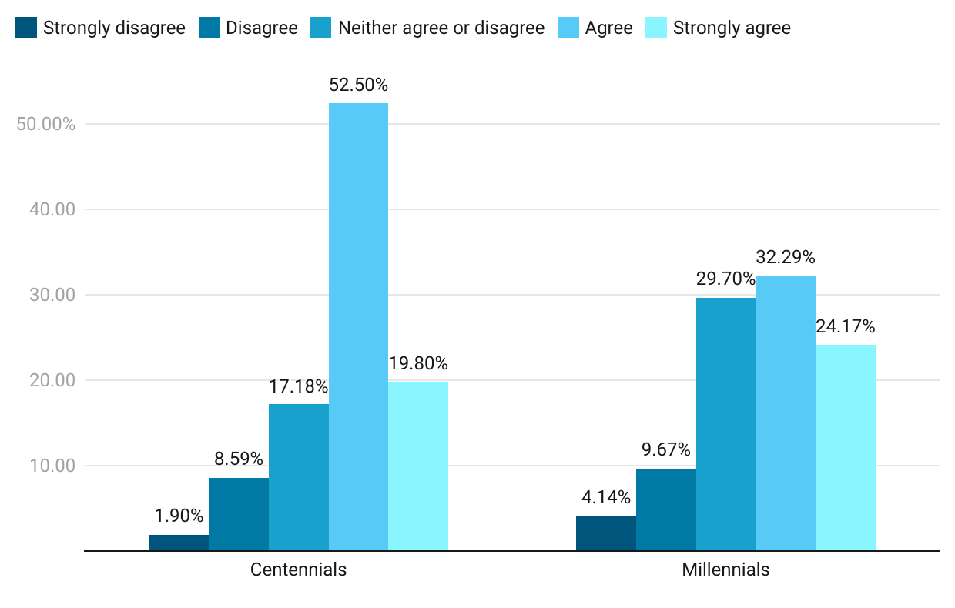
Figure 1: Film and television production companies pay attention to the social atmosphere in society to detect which controversial topics should be dealt with and which should be silenced in their narratives.
No significant differences were found according to the gender of the participants. In Spain, there is a higher level of agreement (M=3.79; SD=0.980) than in Mexico (M=3.54; SD=1.070), [t(653.303)=3.713, p<0.01] around the affirmation of this statement. Similarly, significant differences have been found as a function of age [F(3, 511.803)=7.099, p<0.01], being more significant among the youngest (M=3.93; SD=0.849) than among the oldest (M=3.61; SD=1.186), with centennials showing overwhelmingly greater agreement compared to millennials.
A significant and positive correlation [R(1000)=0.159, p<0.001] was found between the ideological spectrum and the agreement with the statement of this item, with more agreement with the statement in people located more to the right of the ideological spectrum. On the other hand, there is a significant and negative correlation [R(1000)=-0.077, p<0.05] between educational level and agreement with the statement. That is, there is a greater agreement with the lower educational level.
Regarding the consumption of streaming platforms, the degree of agreement with the statement correlates significantly and positively with the consumption of Netflix [R(1000)=0.066, p<0. 05] and HBO [R(1000)=0.092, p<0.01], and negatively with the consumption of Disney+ [R(1000)=-0.093, p<0.01] and Filmin [R(1000)=-0.086, p<0.01], being insignificant in the case of Amazon Prime and other platforms.
Finally, the level of agreement with the statement correlates significantly and positively with consumption motivated by entertainment [R(1000)=0.125, p<0.001] and negatively with consumption motivated by criticism [R(1000)=-0.112, p<0.001], and insignificantly with consumption motivated by accompaniment, art, and education.

  - Bandwagon effect on streaming consumption in Spain and Mexico
Regarding the bandwagon effect, the purpose was to find out whether viewers consider that production companies encourage the presence of trending topics. The statement of this item is as follows: "Production companies encourage the presence of controversial trending topics to increase the number of viewers consuming their products". As shown in Figure 2, there is a clear majority in favor of this statement in the case of centennials (52.50% agree and 19.80% strongly agree).
On the other hand, in the case of millennials, there is also a majority in favor of the affirmation of this section. However, millennials again show more indecision (29.70%) than those younger (17.18%). Therefore, it can be seen that in both generations in Spain and Mexico, there is a belief that production companies use the bandwagon effect in order to get more people to consume their audiovisual products.
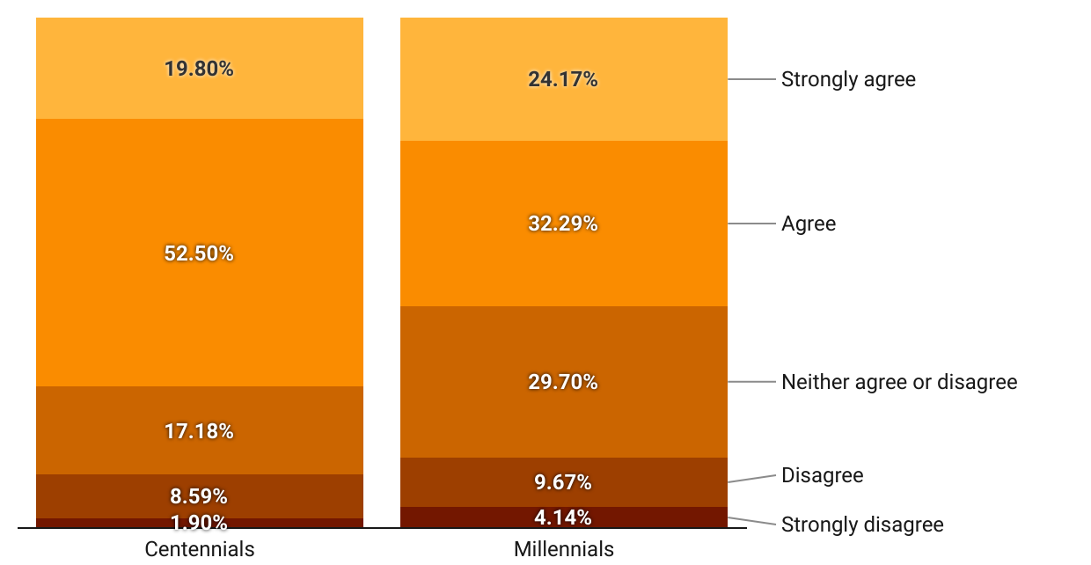
Figure 2: Production companies encourage the presence of controversial trending topics in order to increase the number of viewers consuming their products.
No significant differences were found between Mexico and Spain according to Student's t-test, and likewise, no significant correlation was found between the bandwagon effect and educational level. However, there are significant differences according to age regarding the degree of agreement with the statement [F(3, 494.183)=3.016, p<0.05], being higher among people between 26 and 34 years old (M=4.24; SD=0.817) than among those between 22 and 25 years old (M=3.95; SD=1.113), with younger and older people in intermediate values. That is, there is more agreement between older centennials and younger millennials, i.e., in the middle generation.
Women show a higher level of agreement (M=4.23; SD=0.896) than men (M=4.05; SD=0.949), [t(996)=-3.057, p<0.01] with the statement in this section and, likewise, there is a significant and positive correlation [R(1000)=0.092, p<0.01] between the ideological spectrum and agreement with the statement, with a more significant agreement in people located further to the right of the ideological spectrum.
The degree of agreement with the statement correlates significantly and positively with the consumption of Netflix [R(1000)=0.083, p<0.01] and negatively with the consumption of other platforms [R(1000)=-0.138, p<0.001], being insignificant with the consumption of HBO, Amazon Prime, Disney+ and Filmin. Finally, the degree of agreement with the statement correlates significantly and positively with consumption motivated by entertainment [R(1000)=0.111, p<0.001] and negatively with consumption motivated by criticism [R(1000)=-0.080, p<0.05] and art [R(1000)=-0.084, p<0.01], being irrelevant with consumption motivated by accompaniment and education.

  - Third-person effect on platform consumption in Spain and Mexico
The statement made in the survey to test the third-person effect was the following: " You feel that the content you consume, even if it deals with sensitive topics (politics, abortion, immigration...), in current movies and series does not affect you much because you are aware of what you see, but you think it might affect others more".
Figure 3 shows that 61.10% of centennials agree with the statement, and 61.32% of millennials agree. Therefore, there is a clear affirmative tie between both generations, despite some nuances, such as the fact that 21.95% of centennials strongly agree and 30.92% of millennials agree. Similarly, 39.15% of centennials moderately agree, while 30.40% of millennials do so. All this means that, despite the majority affirmative regarding the self-perceived third-person effect by both generations, the centennials seem to have a slightly lower degree of self-perceived third-person effect.
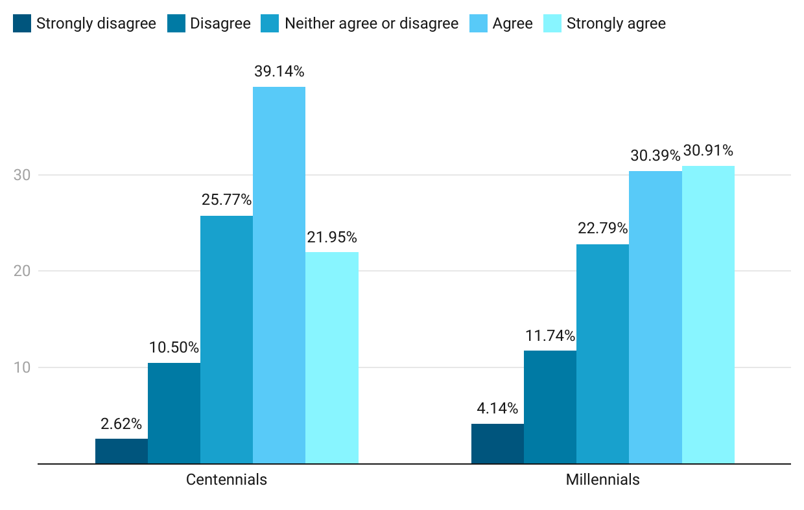
Figure 3: You feel that the content you consume, even if it deals with sensitive topics (politics, abortion, immigration...), in current movies and series does not affect you much because you are aware of what you see, but you think it might affect others more.
In Mexico there is greater agreement (M=3.84; SD=1.077) than in Spain (M=3.64; SD=1.093), [t(1000)=-2.736, p<0.001] on the statement in this section. On the other hand, significant differences have been found according to age regarding the degree of agreement with the statement of this point [F(3, 519.362)=3.889, p<0.01], being higher among people between 26 and 34 years old (M=3.84; SD=1.058) and lower among younger (M=3.59; SD=1.048) and older (M=3.60; SD=1.225) people. That is, younger millennials have a higher degree of third-person effect. Likewise, it is women who show greater agreement (M=3.79; SD=1.045) than men (M=3.59; SD=1.141), [t(789.463)=-2.802, p<0.01] with the statement in this section. No significant correlations were found with either educational level or ideological spectrum.
Regarding the consumption of streaming platforms, the degree of agreement with the statement correlates significantly and negatively with the consumption of Filmin [R(1000)=-0.109, p<0.01], being insignificant with the consumption of Netflix, HBO, Amazon Prime, Disney+ and other platforms. Finally, the degree of agreement with the statement correlates significantly and negatively with consumption motivated by criticism [R(1000)=-0.133, p<0.001], being insignificant with consumption motivated by entertainment, companionship, art, and education.

- Discussion and conclusions
Regarding the perception of millennials and centennials in Spain and Mexico on the ability of production companies to decide which topics to cover and which to silence, in line with Noelle-Neuman (1993) and her theory of the spiral of silence, we found a clear and overwhelming majority in favor of this statement among centennials while, on the other hand, millennials, despite agreeing the most part, feel more indecisive in this regard.
Both generations mostly agree that film and television studios analyze the social environment and the climate of the majority opinion to detect which controversial or polemic topics should appear more in the plots and which should be silenced. However, centennials are much more precise about this than millennials, who are more hesitant to agree or disagree.
Audiences who prefer entertainment and fun when choosing a platform believe that production companies monitor the social environment to decide what topics to cover, while critically motivated audiences perceive this idea as false. The viewers of Netflix and HBO platforms are more in agreement with this idea, while, on the other hand, the consumers of Disney+ and Filmin are less in favor of it. On the other hand, apart from the youngest participants (centennials), the Spanish, those with lower educational levels and right-wing voters tend to agree more with this statement about the spiral of silence and the production companies.
Secondly, regarding the bandwagon effect, Spanish and Mexican audiences of both generations were asked whether they thought that film and television producers encourage controversial trending topics in plots to increase the number of viewers. The following conclusions were obtained: Both millennials and centennials favor this statement. However, it has been found that older centennials (22-25 years old) and younger millennials (26-34 years old) are the ones who agree more with the statement. However, it is again the youngest (centennials) who are clearly more in agreement versus some millennials who show a higher degree of indecision between agreement and disagreement.
This is interesting because it means that in terms of the bandwagon effect, the values stabilize more in the middle ages of the study (the intergenerational). On the other hand, positive correlations have been found showing women and right-wing voters as two profiles very much in favor of the affirmation of this statement. On the other hand, it has been found that Netflix viewers are more in agreement with the use of the bandwagon effect as a strategy of production companies to get audiences. Likewise, it was found that the audience that consumes audiovisuals motivated by entertainment and leisure believes more in this statement than those that watch movies and series motivated by criticism and art.
Finally, regarding the third-person effect, respondents from Spain and Mexico were asked if they believed the content consumed when watching a movie or series affected others more than themselves, especially when dealing with "sensitive" topics such as abortion, politics, or immigration. It has been found that both generations agree for the most part, i.e., they feel that the plots may affect others more ideologically and politically than themselves. However, despite the clear majority, practically the same in both generations, it has been found that the centennials have a slightly lower degree of third-person effect when watching movies and series. On the other hand, Mexicans, women, and younger millennials (26-34 years old) have a higher level of third-person effect when watching audiovisual content.
In conclusion, this research represents centennials in Spain and Mexico as viewers who consume audiovisual entertainment under the idea that movie and series producers, which they watch on their streaming platforms, are the result of a representation focused solely on trendy and controversial topics that exclude other visions. In other words, they consider that entertainment is subjugated to the interests of production companies only interested in generating traffic to their content. However, centennials have a lower degree of a third-person effect than millennials. Thus, centennials are more confident in their critical perceptions of the controversial topics consumed in movies and series, while, on the other hand, millennials approach their perceptions with more caution. Finally, millennials are the ones who feel the greatest degree of indecision and confusion, despite being in majority agreement in the three psychological perceptions discussed in this study, when it comes to these issues.

References
Aguilar-Barojas, S. (2005). Fórmulas para el cálculo de la muestra en investigaciones de salud. Salud en Tabasco, 11 (1-2). https://bit.ly/3uVpMKo
Banning, S. & Sweetser, K. (2007). How Much Do They Think It Affects Them and Whom Do They Believe?: Comparing the Third-Person Effect and Credibility of Blogs and Traditional Medi. Communication Quarterly, 55(4), 451- 466. 10.1080/01463370701665114
Barlovento Comunicación (2021). 4º ola. Barómetro TV-OTT. TV de pago y OTTS. Barloventocomunicación.es. https://bit.ly/3IV4eCS
Barnfield, M. (2019). Think Twice before Jumping on the Bandwagon: Clarifying Concepts in Research on the Bandwagon Effect. Political Studies Review, 18(4), 553-574. doi:10.1177/1478929919870691
Bartels, L. M. (1988). Presidential primaries and the dynamics of public choice. Princeton University Press.
Boyle, M., McLeod, D., & Rojas, H. (2008). The role of ego enhancement and perceived message exposure in third-person perception judgments concerning violent video games. American Behavioral Scientist, 52, 165-185. doi:10.1177/0002764208321349
Casal, J. & Mateu, E. (2003). Tipos de muestreo. Revista de epidemiología y medicina preventiva, 1, 3-7. https://bit.ly/379DT6x
Chevalier Naranjo, S. (16 de septiembre de 2020). El auge de las plataformas de streaming en América Latina. estatista.com. https://bit.ly/3ryTQuZ
Chia, S. C. (2009). When the East meets the West: An examination of third-person perceptions about idealized body image in Singapore. Mass Communication and Society, 12, 423-445. doi:10.1080/15205430802567123
Conners, J. (2005). Undersatanding the Third-person Effect. Communication research trends, 24(2), 2-43.
Contreras Orozco. J. & Pablo Porras. I. (2016). Espiral del silencio en redes sociales. En: Comunicación, ciberperiodismo y nuevos formatos multimedia interactivos (pp. 90-111). Egregius ediciones.
Davison, W. (1983). The third person-effect in communication. The Public Opinion Quarterly, 47(1), 1-15. https://bit.ly/3MEJAd6
Eastman, J. K., Iyer, R., Shepherd, C. D., Heugel, A., & Faulk, D. (2018). Do they shop 314 to stand out or fit in? The luxury fashion purchase intentions of young adults. Psychology & Marketing, 35(3), 220–236. https://doi.org/10.1002/mar.21082
Farjam, M. (2021). The bandwagon effect in an online voting experiment with real political organisations. International Journal of Public Opinion Research, 33(2), 412–421. https://doi.org/10.1093/ijpor/edaa008
Fein, S., Goethals, G. R., & Kugler, M. B. (2007). Social influence on political judgments: The case of presidential debates. Political Psychology, 28(2), 165–192. doi:10.1111/ pops.2007.28.issue-2
Franklin, T. & Shyan, S. (2020). Bandwagon effects in social television: How audience metrics related to size and opinion affect the enjoyment of digital media. Computers in human behaviour, 107, 1-7. https://doi.org/10.1016/j.chb.2020.106270
Guerrero-Solé, F. (2013). El efecto tercera persona en el caso de los medios, la publicidad y contenidos controvertidos. Tripodos, (33), 121-132. https://bit.ly/3J8o3Y8
Gunther, A. C., & Storey, J. D. (2003). The influence of presumed influence. Journal of Communication, 53, 199-215. doi:10.1111/j.1460-2466.2003.tb02586.x
Hahn, K., Lee, H., Ha, S., Jang, S. & Lee, J. (2017): The Influence of "Social Viewing" on Televised Debate Viewers. Political Judgment, Political Communication, 1-19. 10.1080/10584609.2017.1354947
Hernández-Pérez, T., Rodríguez-Mateos, D. (2016). Medición integral de las audiencias: sobre los cambios en el consumo de información y la necesidad de nuevas métricas en medios digitales. Hipertext.net, (14). http://doi.org/10.2436/20.8050.01.32
Ho, S. S., Detenber, B. H., Malik, S., & Neo, R. L. (2012). The roles of value predispositions, communication, and third person perception on public support for censorship of films with homosexual content. Asian Journal of Communication, 22, 78-97. doi:10.1080/01292986 .2011.622775
IAB México (9 de junio de 2017). Millennials: Estudio de consumo de medios entre internautas y mexicanos 2017. Iabmexico.com. https://bit.ly/3NJxz6D
INE. (1 de julio de 2021). Cifras de Población, Ambos sexos, Edad, Total Nacional, 1 de julio de 2021. Ine.es. https://bit.ly/3xaMwIO
INEGI. (2020). Censo de Población y vivienda. Inegi.org.mx. https://bit.ly/3LOF2zn
Kushin, M. J., Yamamoto, M., & Dalisay, F. (2019). Societal Majority, Facebook, and the Spiral of Silence in the 2016 US Presidential Election. Social Media + Society 5(2), 1-11. https://doi.org/10.1177/2056305119855139
Laicock, R. (28 de julio de 2021). Estadísticas de streaming en España. Finder.com. https://bit.ly/35MulOe
López-Bonafont. (2011). La espiral del silencio, los movimientos sociales y la web 2.0. En: Libertades de expresión e información en Internet y las redes sociales: ejercicio, amenazas y garantías (pp. 222-225). Publicaciones de la Universidad de Valencia. https://bit.ly/35QPNBQ
Noelle-Neumann, E. (2010). Turbulencias en el clima de opinión: Aplicaciones Metodológicas de la Teoría de la Espiral del Silencio. CIC. Cuadernos de Información y Comunicación 15, 301 - 318. https://bit.ly/3vVyGJK
Noelle-Neumann, E. (1993). La espiral del silencio. La opinión pública y los efectos de los medios de comunicación. Communication & society, 6(1-2). https://doi.org/10.15581/003.6.35558
Noelle-Neumann, E. (1974). The spiral of silence: A theory of public opinion. Journal of Communication 24, 43–51. doi: 10.1111/j.1460-2466.1974.tb00367.x
Perloff, R. M. (1993). Third-person Effect research 1983-1992: A review and synthesis. International Journal of Public Opinion Research, 5, 167-184. doi:10.1093/ijpor/5.2.167
Perloff, R. M. (1996). Perceptions and conceptions of political media impact: The thirdperson Effect and beyond. In A. Crigler (Ed.), The Psychology of Political Communication (pp. 177-197). Ann Arbor: University of Michigan Press.
Poulakidakos, S., Veneti, A. and Frangonikolopoulos, C. (2018). Post-truth, propaganda and the transformation of the spiral of silence. International Journal of Media and Cultural Politics 14 (3), 367-382. 10.1386/macp.14.3.367_1
Quintas-Froufe, N. & González-Neira, A. (2016). Consumo televisivo y su medición en España: camino hacia las audiencias híbridas. El profesional de la información, 25(3), 376-383. http://dx.doi.org/10.3145/epi.2016.may.07
Rosenthal, S., Detenber, B. H., & Rojas, H. (2018). Efficacy Beliefs in Third-Person Effects. Communication Research, 45(4), 554–576. https://doi.org/10.1177/0093650215570657
Santillán Buelna, J. R. (2015). Teorías de la comunicación y opinión pública | Theories of Communication and Public Opinion. Razón Y Palabra, 19(2_90), 672–684. https://bit.ly/3pSUzWw
Shim, K., Klive, S-K. (2018). Who creates the bandwagon? The dynamics of fear of isolation, opinion congruency and anonymity-preference on social media in the 2017 South Korean presidential election. Computers in Human Behavior, 86, 181-189. 10.1016/j.chb. 2018.04.012
Statista Research Department. (2 de julio de 2021). Streaming en América Latina – Datos estadísticos. Statista.com. https://bit.ly/3oph04J
Soriano Rodríguez, A. M. (2015). Diseño y validación de instrumentos de medición. Diá-Logos, (14), 19–40. https://doi.org/10.5377/dialogos.v0i14.2202
Sun, Y., Pan, Z. D., & Shen, L. J. (2008). Understanding the third-person perception: Evidence from a meta-analysis. Journal of Communication, 58, 280-300. doi:10.1111/j.1460- 2466.2008.00385.x
Sundar, S. S. (2008). The main model: A heuristic approach to understanding technology effects on credibility. In M. J. Metzger, & A. J. Flanagin (Eds.), Digital media, youth, and credibility (pp. 73–100). Cambridge, MA: The MIT Press.
Tamayo, G. (2001). Diseños muestrales en la investigación. Semestre económico, 4(7), 1-14. https://bit.ly/3ulSZzg
Valdez, A. & Amparo. D. (2011). ¿Qué mueve a los votantes? Un análisis de las razones y sinrazones del comportamiento político del elector. Razón y Palabra, (75). https://bit.ly/3utpKt4
Wei, R., & Lo, V. H. (2013). Examining sexting's effect among adolescent mobile phone users. International Journal of Mobile Communications, 11, 176-193. doi:10.1504/ ijmc.2013.052640
Werder, S. (2013). ¿Ficción o hiperrealidad? Un estudio comparado de los relatos "Tlön, Uqbar, Orbis tertius״ ,de Jorge Luis Borges y "La salida״ ,de Daniel Kehlmann”. Literatura y lingüística, (28), 127-121, http://dx.doi.org/10.4067/S0716- 58112013000200007

